PRACTICAL NO.1:

A.

n=input("Enter your name:")

a=int(input("Enter the age:"))

cy=0

cy=2024+(100-a)

print(n)

print("The year you will turn 100:",cy)

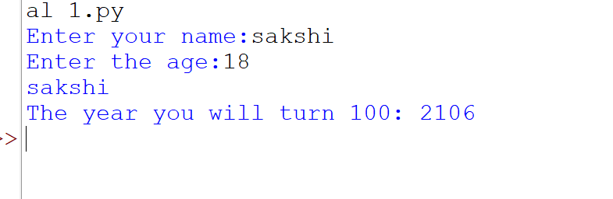

B.

a=int(input("Enter the number:"))

if a%2==0:

print(a,"even number")

else:

print(a,"odd number")

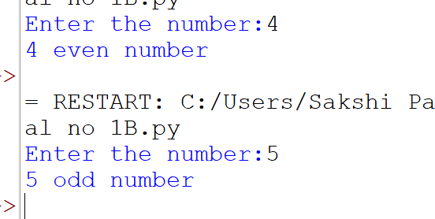

C.

n=int(input("Enter a number:"))

n1,n2=0,1

count=0

if n==0:

print(n1)

elif n==1:

print(n1,n2)

else:

print("Fibonacci series:")

while count<n:

print(n1)

temp=n1+n2

n1=n2

n2=temp

count+=1

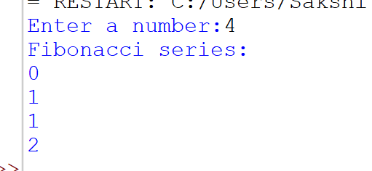

D.

num=int(input("Enter a number:"))

r=0

rev=0

while num!=0:

r = num % 10

rev = rev \* 10 + r

num=int(num/10)

print("Reversed Number: ",rev)

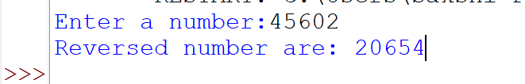

E.

def arm():

num=int(input("Enter a number:"))

r=0

rev=0

n=num

s=0

while num!=0:

r=num%10

s=s+r\*\*3

num=int(num/10)

if n==s:

print("It is Armstrong")

else:

print("It is not Armstrong")

arm()

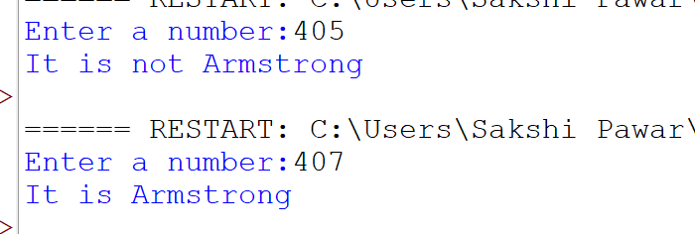

def palin():

num=int(input("Enter a number:"))

r=0

rev=0

n=num

while num!=0:

r = num % 10

rev = rev \* 10 + r

num=int(num/10)

if(n==rev):

print("It is palindrome")

else:

print("It is not palindrome")

palin()

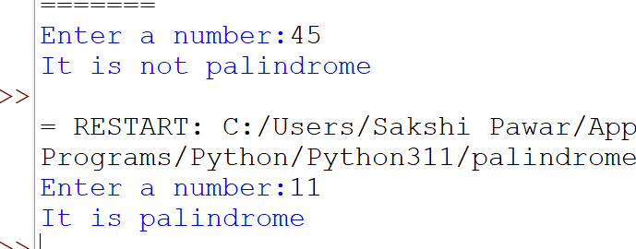

F.

def factorial(n):

if n == 1:

return n

else:

return n\*factorial(n-1)

num = 4

if num < 0:

print("Sorry, factorial does not exist for negative numbers")

elif num == 0:

print("The factorial of 0 is 1")

else:

print("The factorial of", num, "is",factorial(num))

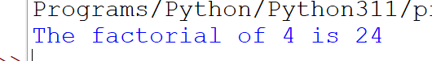

PRACTICAL NO.2

A.

def vowel(x):

if x in ["a", "e", "i", "o", "u", "A", "E", "I", "O", "U"]:

return "True"

else:

return "False "

a = input ("Enter the letter :- ")

print (vowel(a))

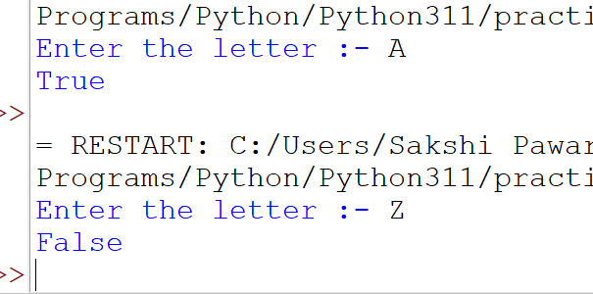

B.

def str1(A):

b=0

for i in A:

b+=1

print("The length of string is:",b)

str1("Sakshi")

C.

def histogram( items ):

for n in items:

output = ''

times = n

while( times > 0 ):

output += '\*'

times = times - 1

print(output)

histogram([4,9,7])

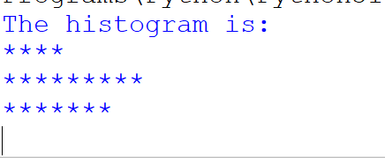

PRACTICAL NO.3

A.

L1=[1,2,3,5,4]

L2=[3,4,5,10,0]

for i in L1:

if i in L2:

print(i)

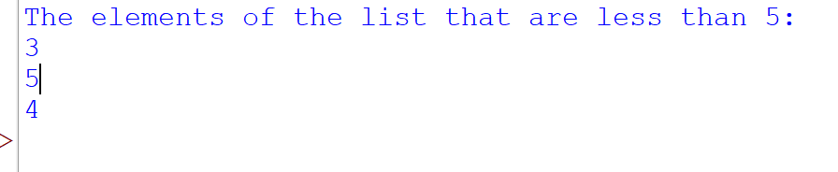

s="Hello World!! Welcome To Python Programming."

count=0

for i in s:

if (i.islower()):

count=1+count

print("Count of lower case:",count)



def ana(str1,str2):

if (sorted(str1)==sorted(str2)):

print("The string is anagram")

else:

print("The string is not anagram")

str1="abc"

str2="bac"

ana(str1,str2)

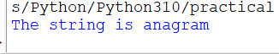

import string

def pana(str1):

charat="abcdefghijklmnopqrstuvwxyz"

for char in charat:

if char not in str1.lower():

return False

else:

return True

str1="The quick brown fox jumps over the lazy dog"

if(pana(str1)==True):

print ("Yes it is Panagram.")

else:

print("it is not Panagram.")



PRACTICAL NO 4

dict1={10:5,4:2,100:50}

d=sorted(dict1.values())

print(d)



d1={"Name":"Sakshi","Age":18}

d2={"Roll NO":554,"Year": "SY"}

d3={}

for i in (d1,d2):

d3.update(i)

print("Dictionary after Concatination:",d3)

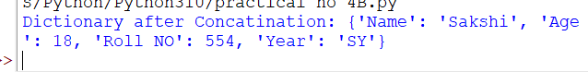

dict1={10:20,50:60,40:20,20:17}

val=sum(dict1.values())

print(val)



dict1={10:20,50:60,40:20,20:17}

dict1[60]=20

print("Dictionary After Adding:",dict1)



dict1={10:20,50:60,40:20,20:17}

if 10 in dict1:

print(True)

else:

print(False)



d1={"Name":"Sakshi","Age":18}

del d1["Name"]

print(d1)



dict1={10:20,50:60,40:20,20:17}

d=dict1.values()

mul=1

for i in d:

mul=mul\*i

print("Multiplication of items:",mul)

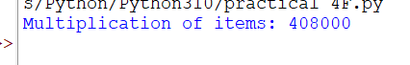

PRACTICAL NO:5

Q1:

def fails():

try:

x=1/0

except ZeroDivisionError as err:

print("Handling run-time Error",err)

fails()

Q2:

def importerr():

try:

import xyz

except ImportError:

print("Import Error Exception")

finally:

print("Executing Finally Cluase")

importerr()

Q3:

def indexerr():

try:

l1=[1,2,3,4,30]

print(l1[20])

except IndexError:

print("Result is not Found")

finally:

print("Executing Finally Cluase")

indexerr()

Q4:

def keyerr():

try:

dict={"Name":"Zara","Age":7,"Class":"First"}

print(dict["RollNo"])

except KeyError:

print("Key Errer Exception")

finally:

print("Executing Fanally Clause")

keyerr()

Q5:

def ioerr():

try:

fo=open("file1.txt","r")

str1=fo.write("This is my file")

print(str1)

except IOError:

print("Error: Cannot read Data")

ioerr()

\*FILE HANDLING\*

Q6:

import os

f1=open("file1.txt","w+")

line1="Hello Pinky!!!"

f1.write(line1)

f1.close()

f1=open("file1.txt","r")

ans=f1.read()

print(ans)

f1.close()

Q7:

fo=open("file11.txt","r")

file11=fo.read()

fo.close()

f1=open("file12.txt","w")

f1.write(file11)

f1=open("file12.txt","r")

file12=f1.read()

print("the second file content is:",file12)

f1.close()

Q8:

fo=open("file1.txt","w")

fo.write("Good Evening\n Python is great programming language \n seek and tell position ")

fo.close()

fo=open("file1.txt","r+")

str1=fo.read(20)

print("Read string is:",str1)

position=fo.tell()

print("Current file position:",position)

position=fo.seek(0,0)

str1=fo.read(10)

print("Again read string is:",str1)

Q9:

fo=open("file2.txt","a")

fo.write("\nthis is text for appending")

fo.close()

fo=open("file2.txt","r")

str1=fo.read()

print("the content after appending",str1)

fo.close()

Q 10:

fo=open("file2.txt","w")

fo.write("Hello everyone \n Good Morning \n Have a Good day")

fo.close()

fo=open("file2.txt","r")

line1=fo.readlines()

print(line1[-1])

fo.close()

Q11:

import linecache

num=0

fo=open("file2.txt","r")

for line in fo:

num +=1

print("number of lines:",num)

n=input("Enter last n lines to read:")

for i in range(num,num-n,-1):

print(linecache.getline("file2.txt",i),end="")

import linecache

num=0

fname=input("Enter file name:")

with open(fname,"r")as f:

for line in f:

num+=1

print("Number of lines:",num)

n=int(input("Enter last n lines to read:"))

for i in range(num,num-n,-1):

print(linecache.getline("file2.txt",i),end=" ")

